Center for Autism and Behavioral Disorders

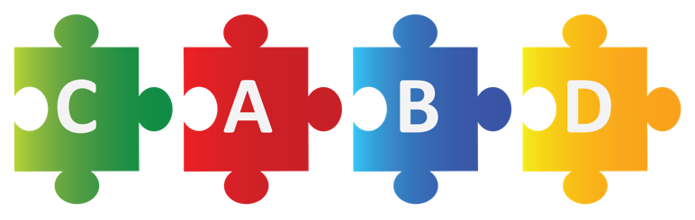

“Cultivating Beautiful Minds without Limits”

Phone: 806) 239-713 • http://www.cabddallas.com

Online Enrollment Request

- Patient Full Legal Name
_______________________________________________________________
- Parent / Legal Guardian Full Legal Name
_______________________________________________________________
- Patient Date of Birth
_______________________________________________________________
- Insurance Subscriber (Ex: Blue Cross Blue Shield, Tricare, Cigna, Aetna, etc.)
_____________________________________________________________
- Insurance ID # / Group #
_______________________________________________________________

- Patient Home Address
_______________________________________________________________
- Parent / Legal Guardian Phone #
_______________________________________________________________
- Parent / Legal Guardian Email
______________________________________________________________

- Does your child have an initial diagnosis from a developmental pediatrician? (ASD, Anxiety, Depression, Stuttering, Apraxia, etc.) Please circle YES or NO.
Yes No
- Insurance Card (Upload Picture)

